**DATABASE TASKS KN ABHISHEK**

Task 1: **NSSCE**

**ECE**

1. ER Diagram:

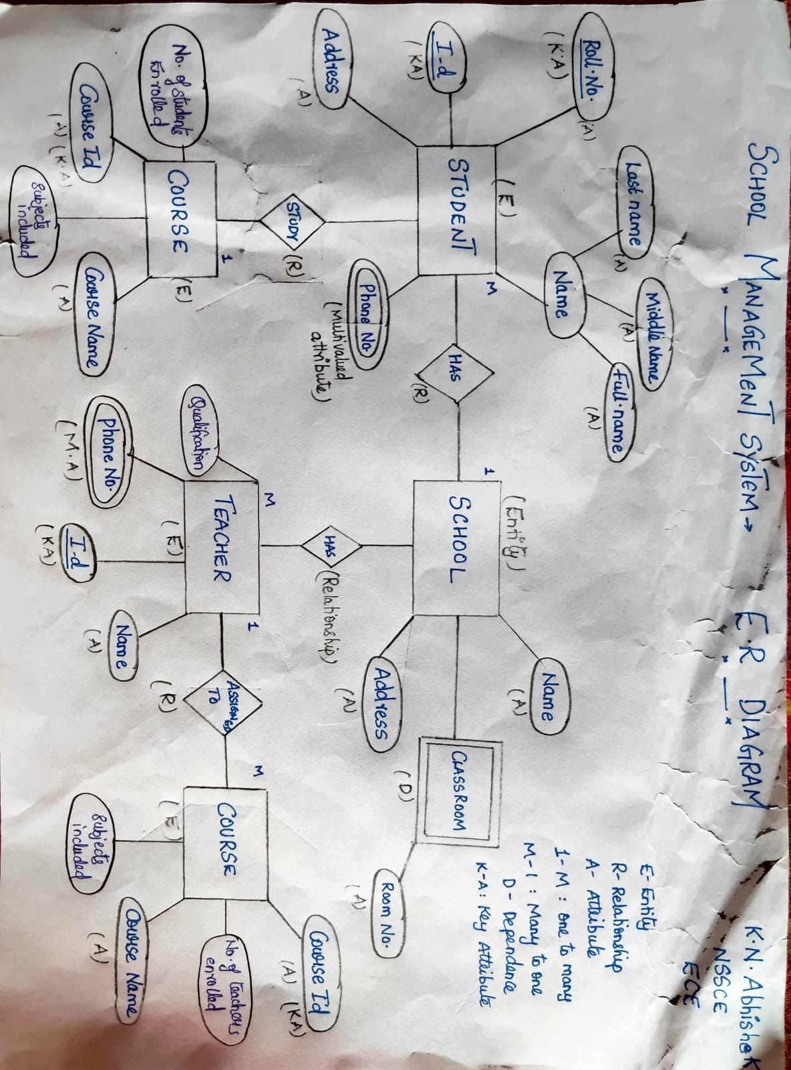

1. Setting up the Postgre: on machine and creating a Database:

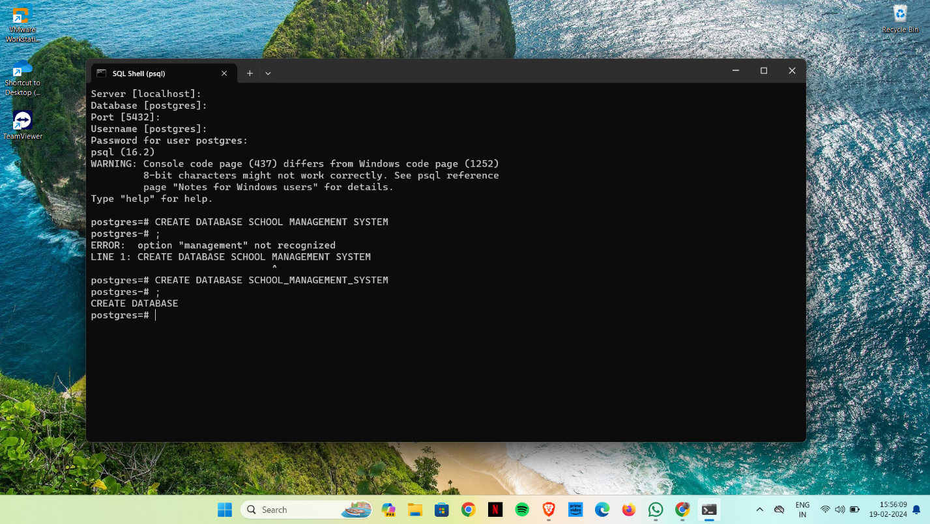

1. Adding Tables:

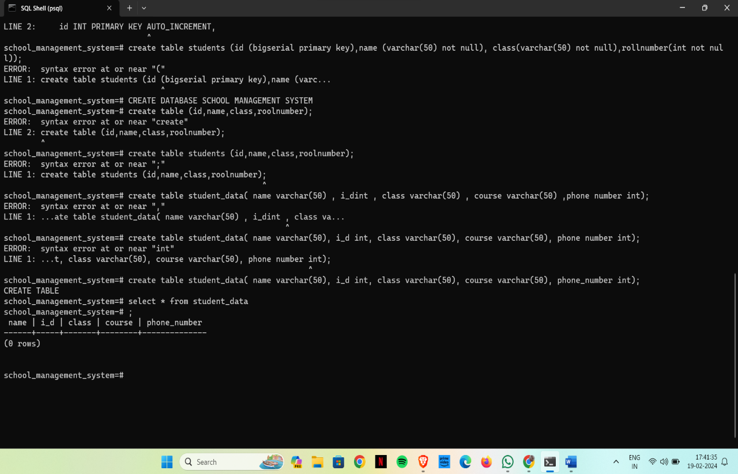

1. Adding Data to Table:

Student data:

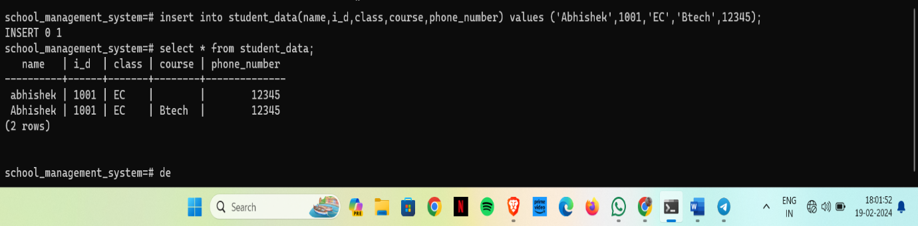

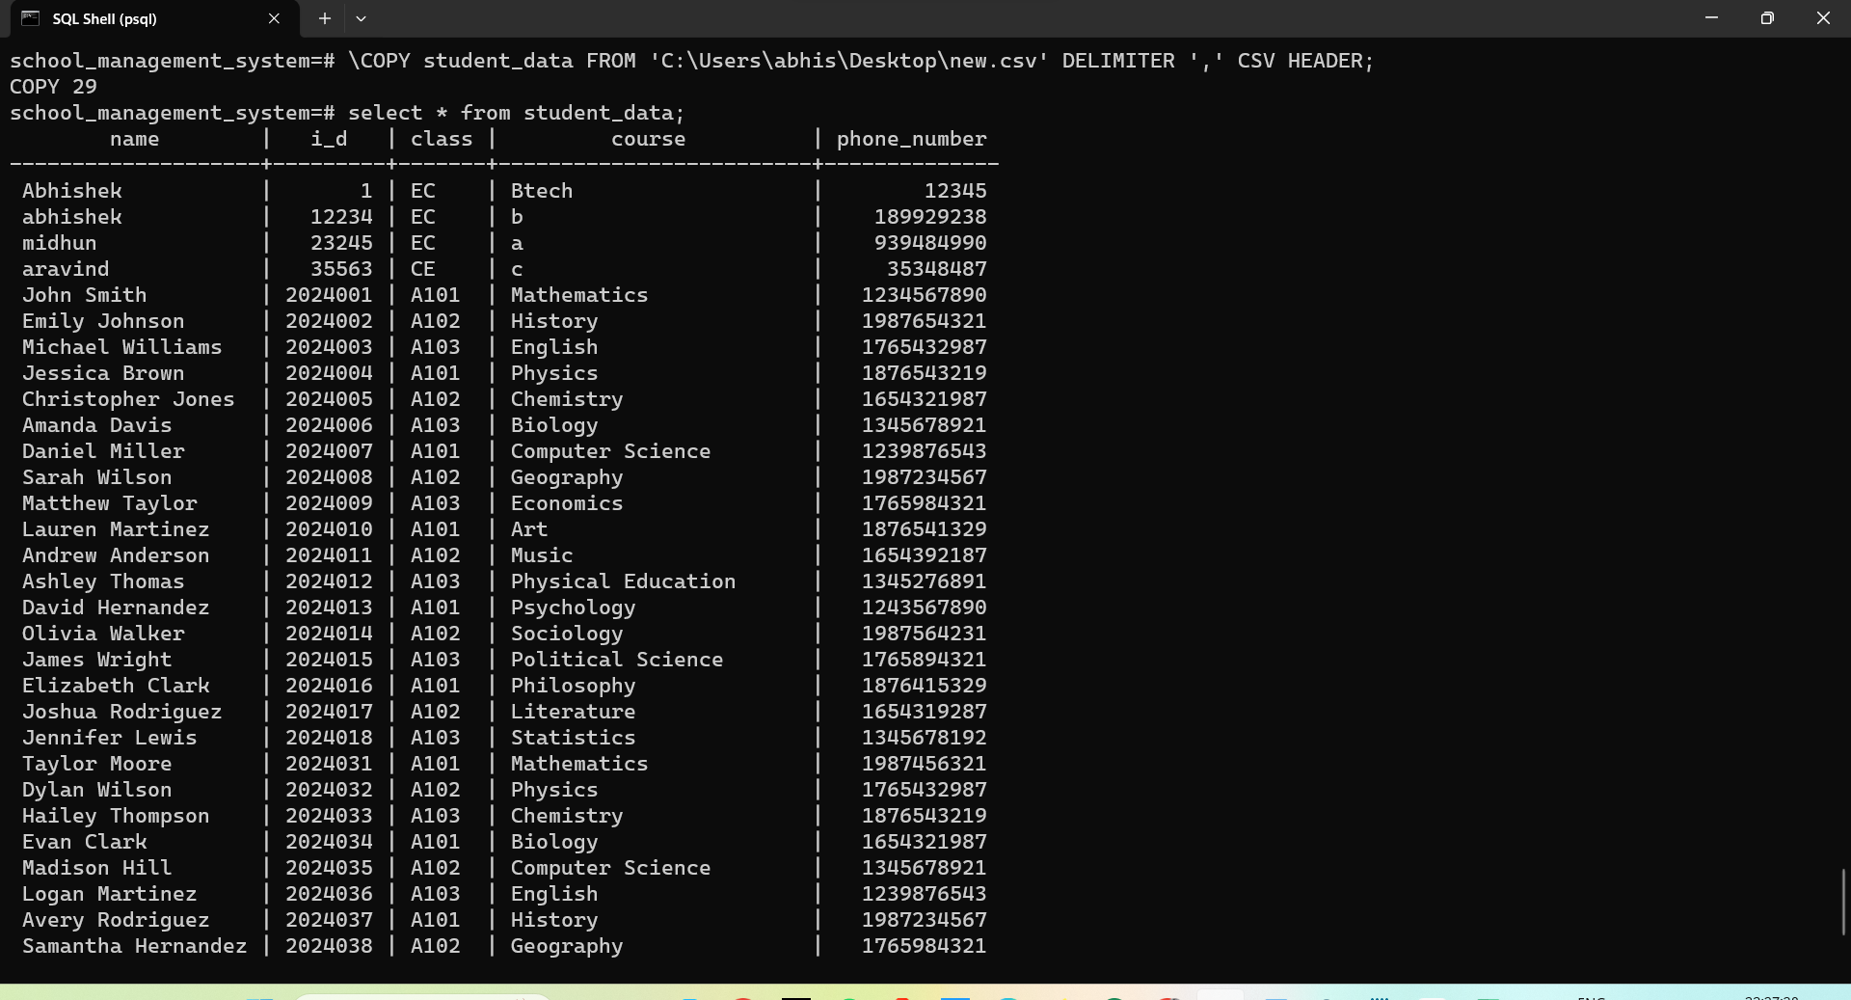

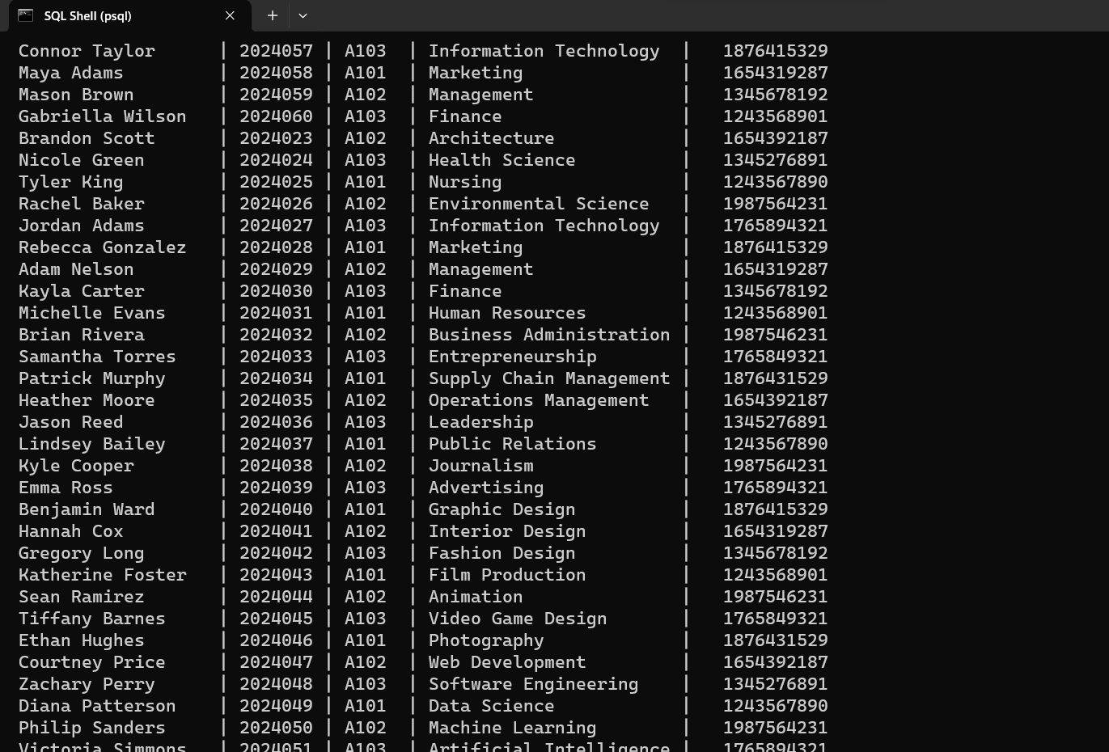

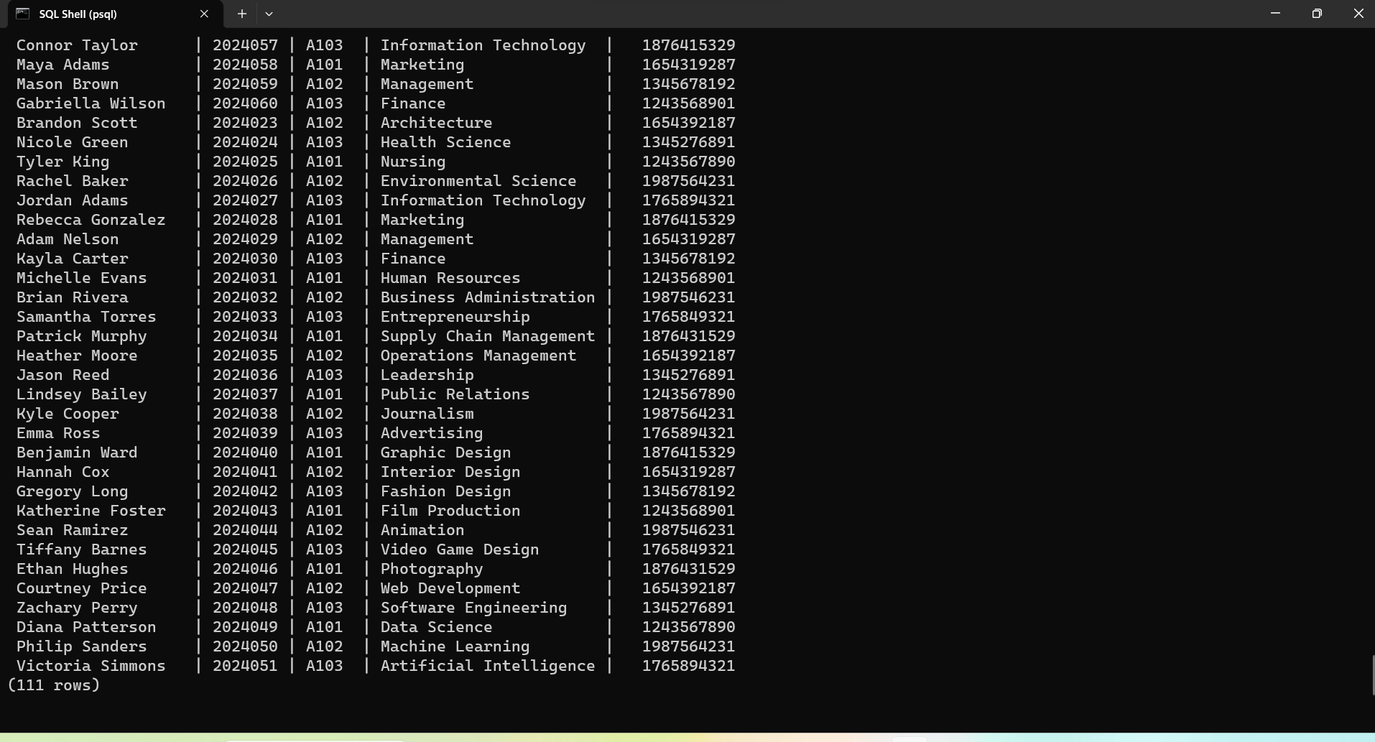

* 1. Teacher data:

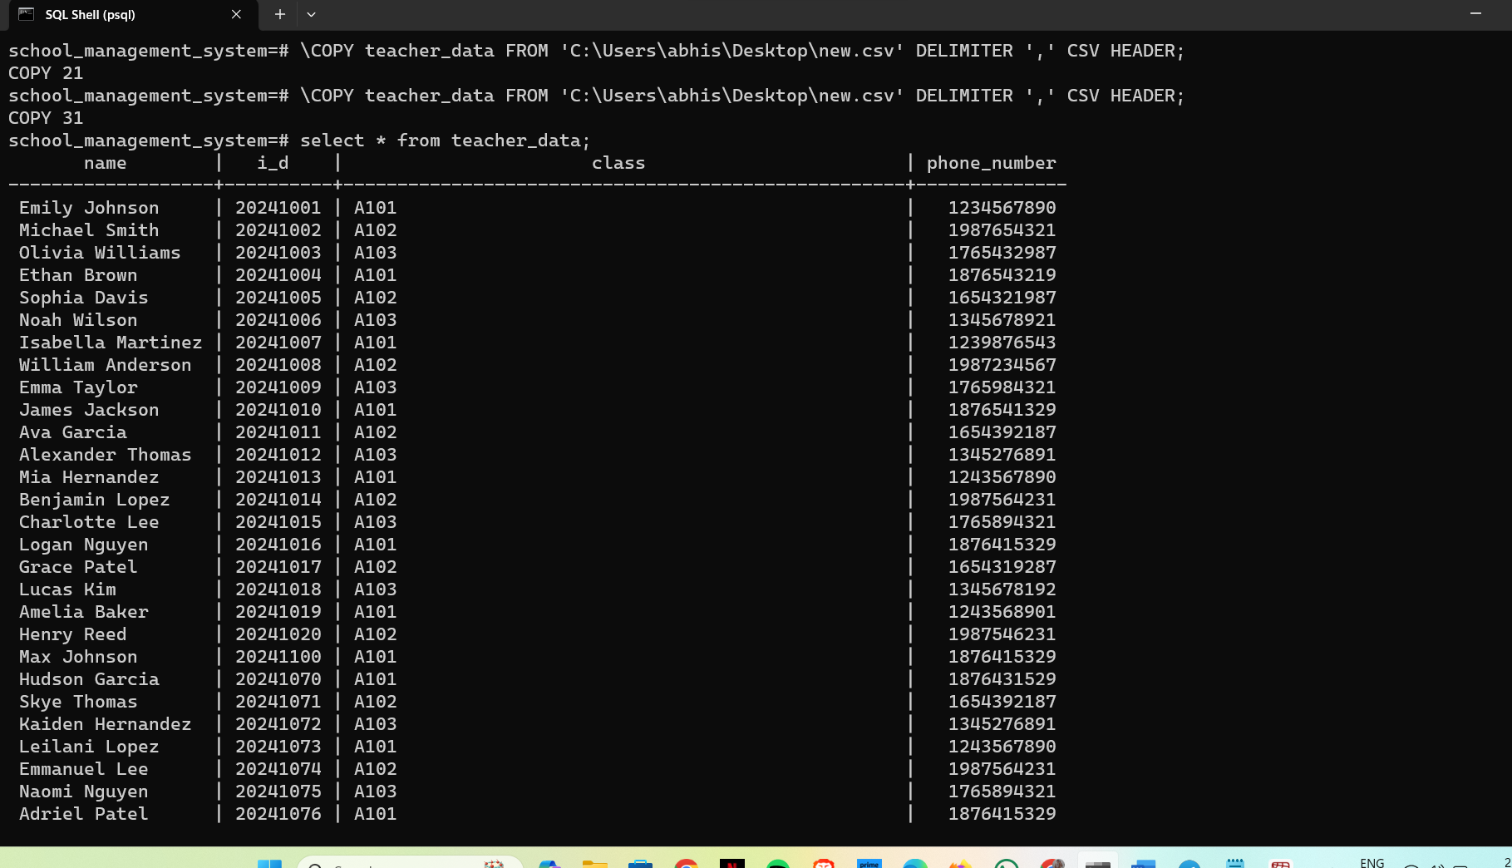

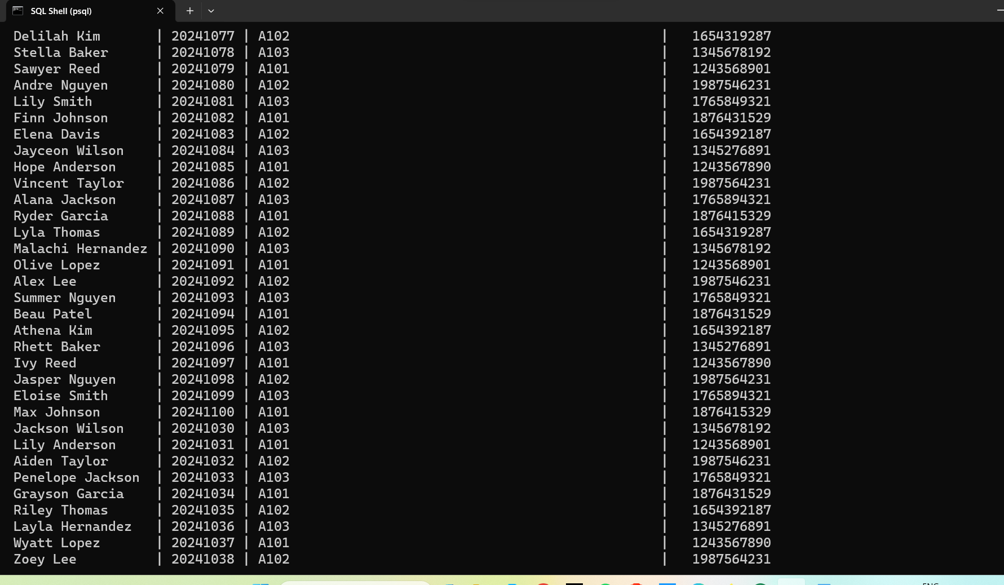

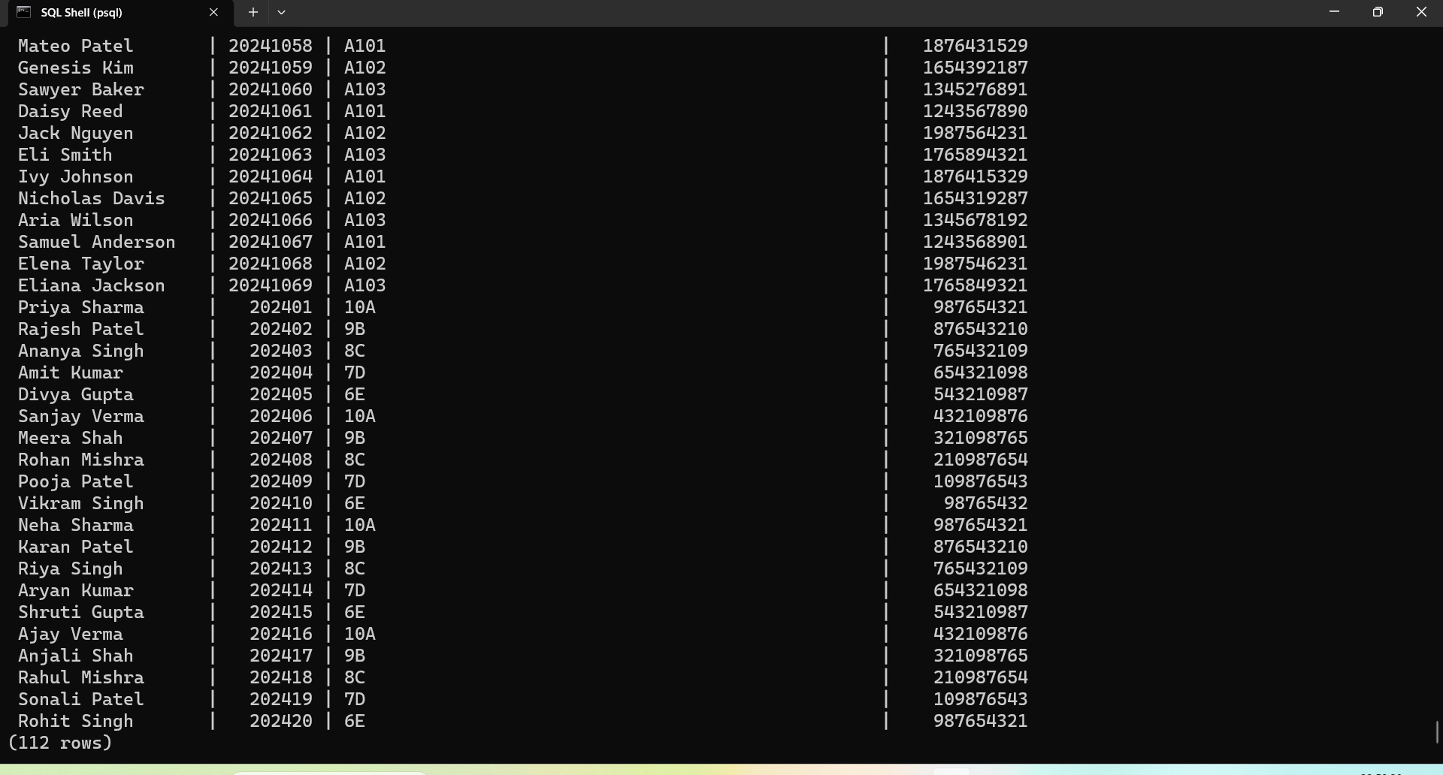

1. Writing a select query with and without condition:

With condition:

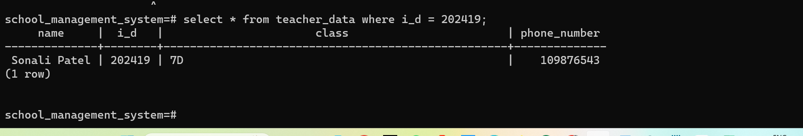

Without condition:

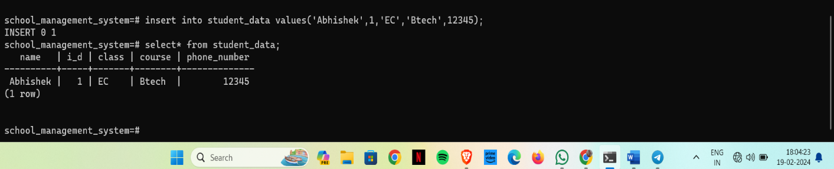

1. Inserting a data into table & deleting a data:

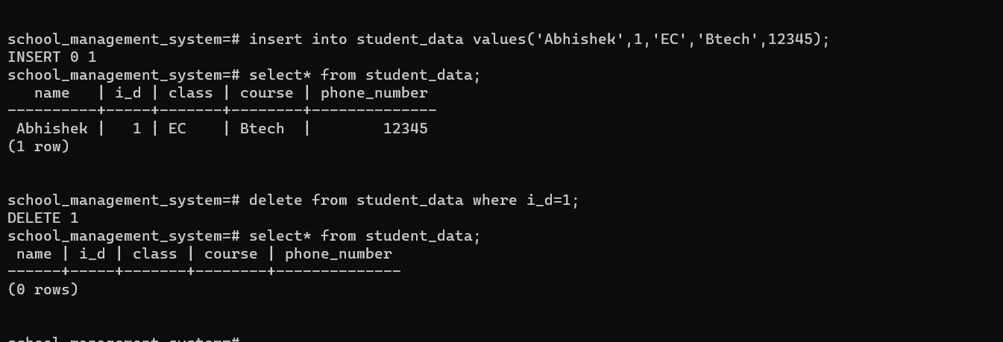

1. Updating a data in the table:

